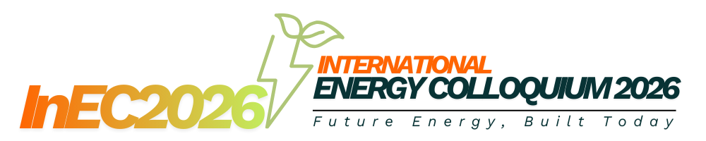

Abstract Template (≈ 200–300 words)

Title
Use a concise and informative title that reflects the main contribution of the study. Avoid abbreviations where possible.

Authors
Author Name¹, Author Name²
¹Affiliation, Institution, Country
²Affiliation, Institution, Country
Corresponding author email

Abstract Guideline
- Begin with a brief background that introduces the broader context of the study and its relevance to energy research or technology. Clearly state the problem or knowledge gap that motivates the work. Next, describe the main objective(s) of the study.
- Summarise the methodology used, including experimental, numerical, analytical, or modelling approaches, without excessive technical detail. Highlight the key results or findings, focusing on what is novel or significant. Where appropriate, include quantitative results.
- Conclude the abstract by stating the main implication or significance of the work for energy systems, technology development, safety, sustainability, or future research.
- The abstract should be written as a single paragraph, in clear and concise English, and should not include references, figures, or equations.

Keywords:
Provide 3–5 keywords separated by commas (e.g., Nuclear energy, Radiation shielding, Advanced materials)

THERMAL–HYDRAULIC ANALYSIS OF A COMPACT BOILING WATER REACTOR CORE USING HALEU FUEL
A. Ahmad¹, B. Hassan¹, C. Rahman²
¹Faculty of Chemical and Energy Engineering, Universiti Teknologi Malaysia, Malaysia
²Department of Nuclear Engineering, Malaysian Nuclear Agency, Malaysia
Corresponding author: a.ahmad@utm.my

Abstract
The development of compact nuclear reactors has gained increasing attention due to their potential for flexible deployment and enhanced safety features. In this study, a thermal–hydraulic analysis of a compact boiling water reactor core fueled with high-assay low-enriched uranium (HALEU) is presented. The objective of this work is to evaluate the temperature distribution and coolant flow characteristics of the reactor core under steady-state operating conditions. A simplified homogeneous core model was developed, and single-phase heat transfer analysis was performed using computational fluid dynamics simulations. Key parameters, including coolant velocity, fuel surface temperature, and heat flux distribution, were analysed to assess thermal performance and safety margins. The results indicate that the maximum fuel surface temperature remains below the allowable design limit, while adequate coolant flow is maintained throughout the core region. Regions of higher heat flux were observed near the central core area, consistent with the assumed power distribution. The findings demonstrate that the proposed compact core design exhibits favourable thermal–hydraulic behaviour under nominal conditions, supporting its feasibility for low-power research or microreactor applications. This study provides a foundation for future work incorporating two-phase flow effects and coupled neutronic–thermal analyses to further enhance the accuracy of reactor performance assessment.

Keywords:
Thermal hydraulics, Boiling water reactor, HALEU fuel, Compact reactor, CFD analysis

